NCL-2000 FAN MOTOR REPLACEMENT
by Gale Heise, KM4DR

Fred Gerken, KC5RT, has been a tremendous help to me troubleshooting an NCL-2000 amplifier and replacing Q1, the bias regulator transistor. When I set out to replace the fan motor Fred asked me to document the process for his website.
In summary, if you're interested in changing out the original fan motor and blower wheel, it can be accomplished with minimum modifications provided you have the same motor as described in the following information. Hopefully, this information will help you to avoid some of the pitfalls encountered and mistakes made along the way.
After researching comments on the internet and it was quickly learned that originally, there were three different fan motors utilized in the NCL-2000. My NCL-2000 has a Howard Model 1175-16-4065, 115v, 60 Hz, 30 watts/.008 HP and Clockwise Rotation when viewed facing the long part of the shaft. The motor housing measures 1 7/8"(shaft axis) x 2 1/2" x 3 1/16". This motor fits through a hole in the chassis which is about 2 3/4" x 3 3/16" and the dimension from the chassis to the mounting plate is 1 15/16".
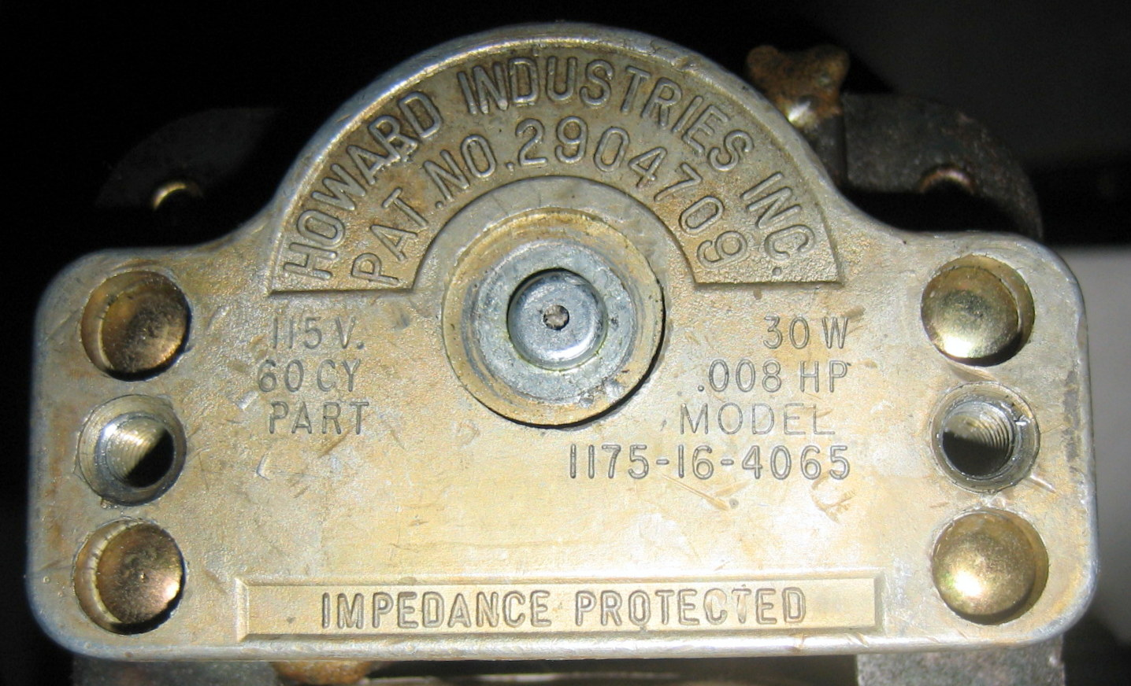
ORIGINAL HOWARD INDUSTRIES FAN MOTOR INFORMATION
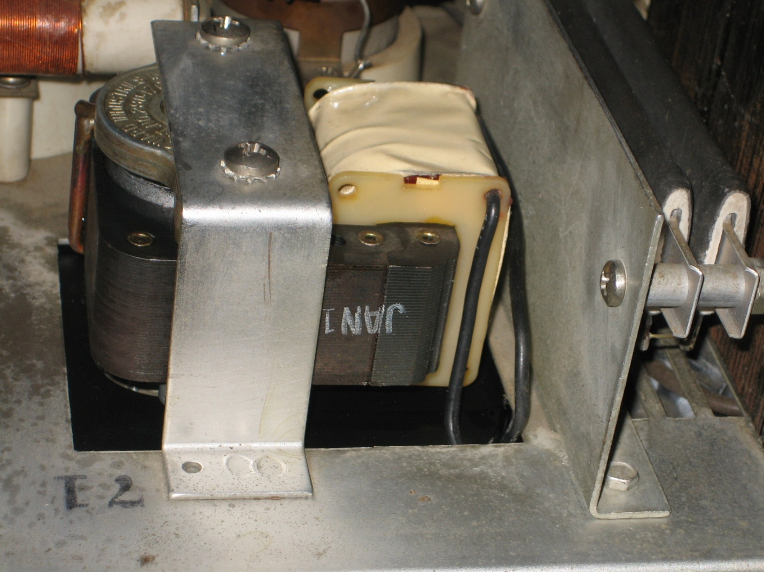

ORIGINAL MOTOR MOUNTED VIA BRACKET

My brother Jan, K4QD, replaced the fan motor in an NCL-2000 but he had to cut the mounting bracket to do so. At the outset, I was hopeful to find a replacement motor without having to cut or modify the mounting bracket.

Eventually, through numerous internet searches I came across a post by Howard, W4HLR, that indicated he found a potential replacement motor and blower wheel on the emotorstore.com website. Unfortunately, the blower wheel (Fasco 1-6039) was too large to fit through the original fan housing (3" vs. required 2 3/4" or less). The blower motor (Fasco K612) has great potential even though the shaft size is 1/4" vs. the original 3/16".

I must say that Craig Bagdon, the representative at the emotorstore.com, provided absolutely fantastic customer service providing me with photos and critical dimensions of the motor during my initial study of the K612. If you want to call Craig he may be reached at 866-698-3316 but I found his communication skills via email to be excellent.

Being satisfied I could reasonably adapt the K612 it was ordered online through the emotorstore.com website. I received the motor in a few days via UPS shipment. The motor comes set up with the required Clockwise Rotation but it's possible to mechanically flip the rotation Counter Clockwise for other applications. I labeled the motor when I unpacked it to keep from accidently assembling CCW since I planned to disassemble the motor.

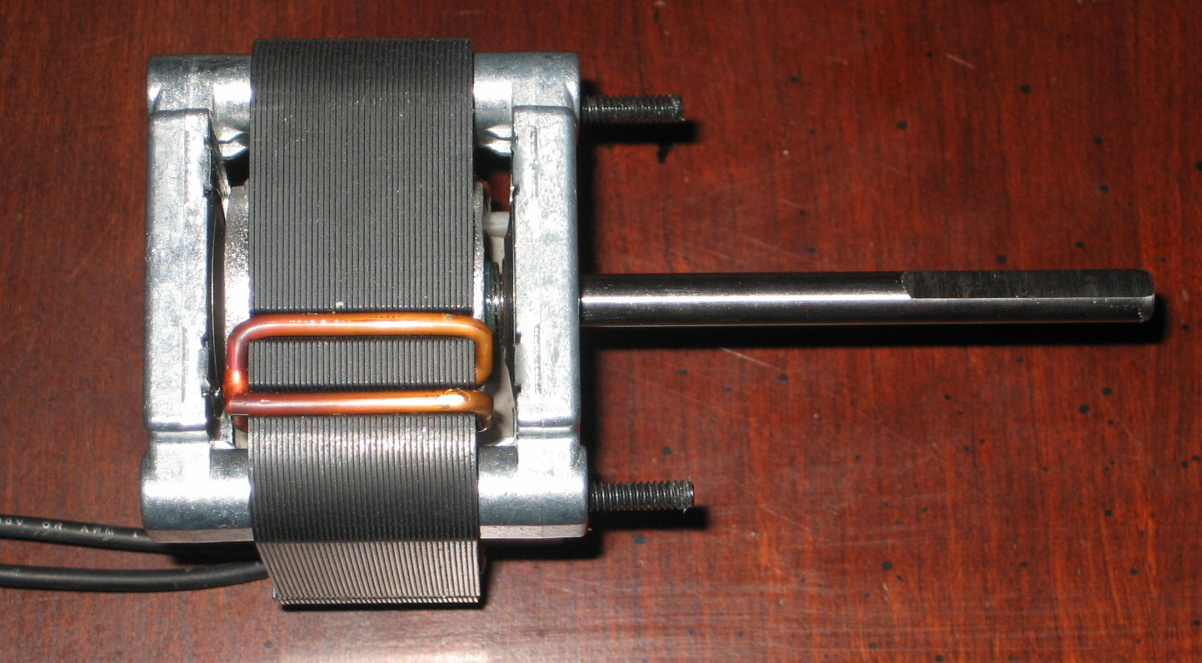

Based upon a review of the K612 specifications, the shaft needs to be shortened. The required amount of shaft removal may be determined once the blower wheel, motor and housing are assembled for a tolerance test fit.

The overall dimensions appear to be very close to the original motor and the motor should be able to be mounted without major modifications to the mounting bracket or fan housing.
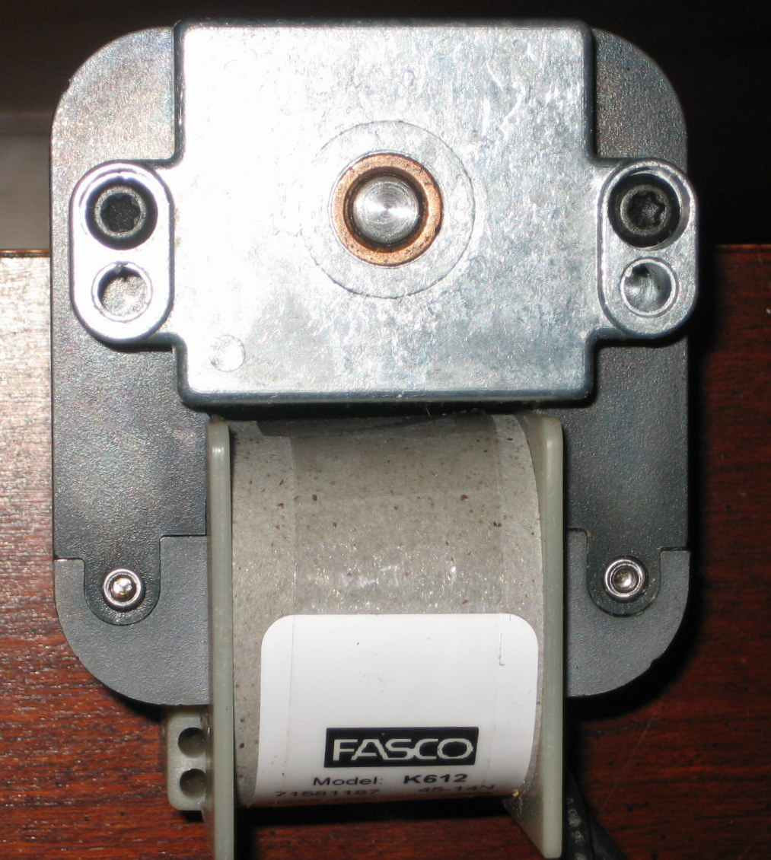

FASCO K612 120V REPLACEMENT MOTOR

There are two long black bolts that hold the motor together. Prior to final assembly of the motor, housing and blower wheel the bolts should be cut off flush with the edge of the motor. If not flush they may need to be ground down so that they don't protrude and conflict with the fan housing.

Please note the bolt heads in the previous photos. The heads of these two bolts are a "star" type head so if you don't have one, you will need to purchase a "star" type wrench. Fortunately, I had already purchased one when I rebuilt an old Clipperton-L amplifier.

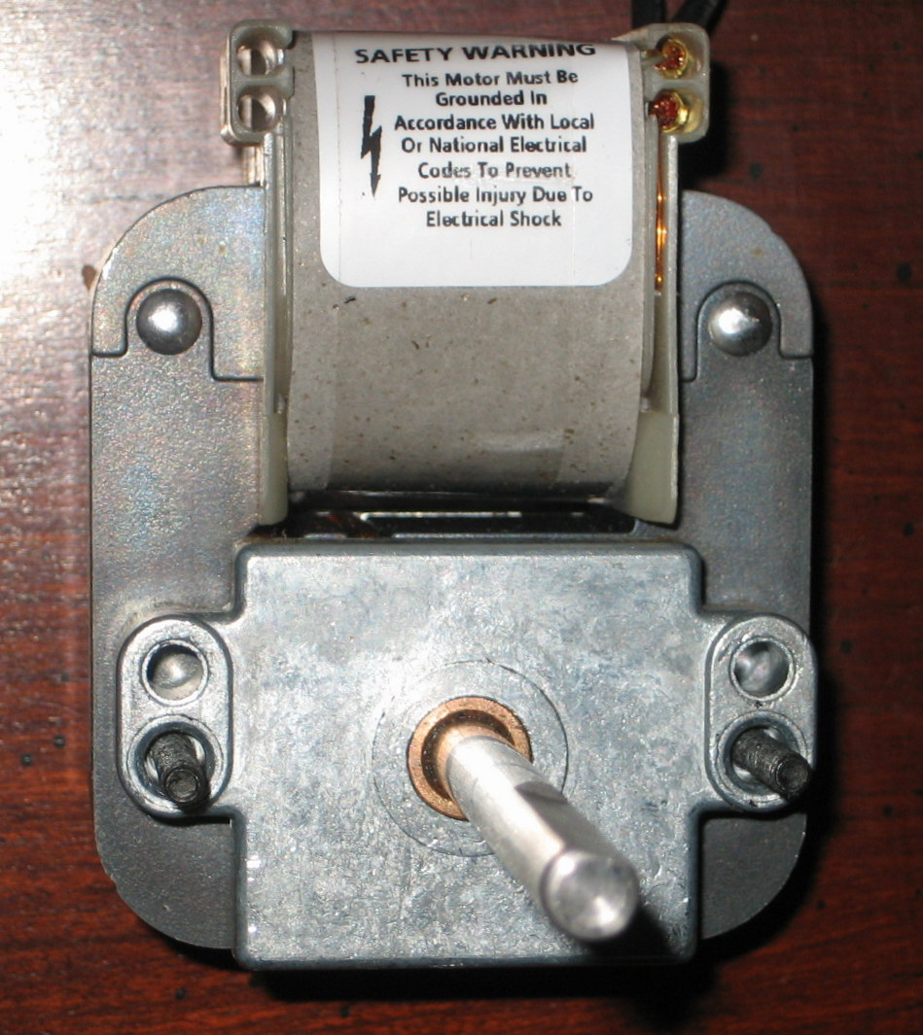

FASCO K612 SHAFT SIDE VIEW

After examining the motor more closely I noticed there were two cast holes next to the motor assembly bolts. I could potentially tap these holes to mount the fan to the mounting bracket and fan housing to the fan motor. If I were really lucky, these holes would be the same dimensions as those in the mounting bracket and on the fan housing.

I set the fan housing atop the motor and found the cast holes do in fact align perfectly. This means not only can the fan housing mount with the original hole locations but the motor may be mounted directly to the chassis mounting bracket without modification as well.
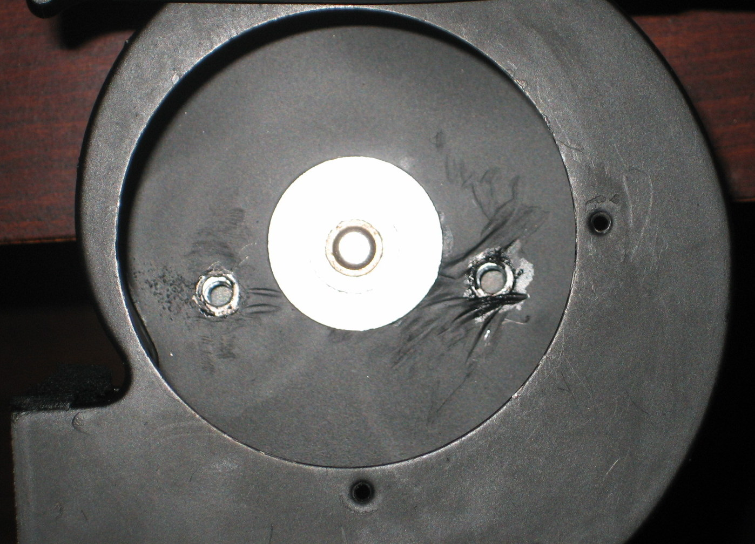

I needed to determine if the cast holes were sized to be tapped for US standard bolts or metric. A set of drill bits was utilized to determine an 11/64" drill was very close to the size of the cast hole. Upon checking a tap and drill chart for US and Metric bolts I came to the conclusion the existing hole is good for a #12 x 24 thread. Unfortunately, this isn't commonly found at Lowe's so a trip to Fastenal to order bolts was required.

The previous experience with bolts that fasten the motor to the fan housing was not good. The bolts had seized in the aluminum motor housing. I had to grind off the bolt heads, remove the fan housing and then remove the two seized bolts with a pair of vise grips. Fortunately, the bolts didn't twist off in the motor. Grinding really messed up the paint job so I repainted the housing.

Because of the seizing problem I decided to utilize hex head (Allen Wrench) bolts. The maximum bolt length allowed is 1/2". It's recommended to avoid utilizing stainless bolts since they really tend to seize in aluminum and twist off easily. The bolts from Fastenal are steel and black in color. So hex head, #12 x 24 thread, 1/2" long, steel and black is the spec. for the Fastenal bolts. They were expensive due to a special order and shipping.
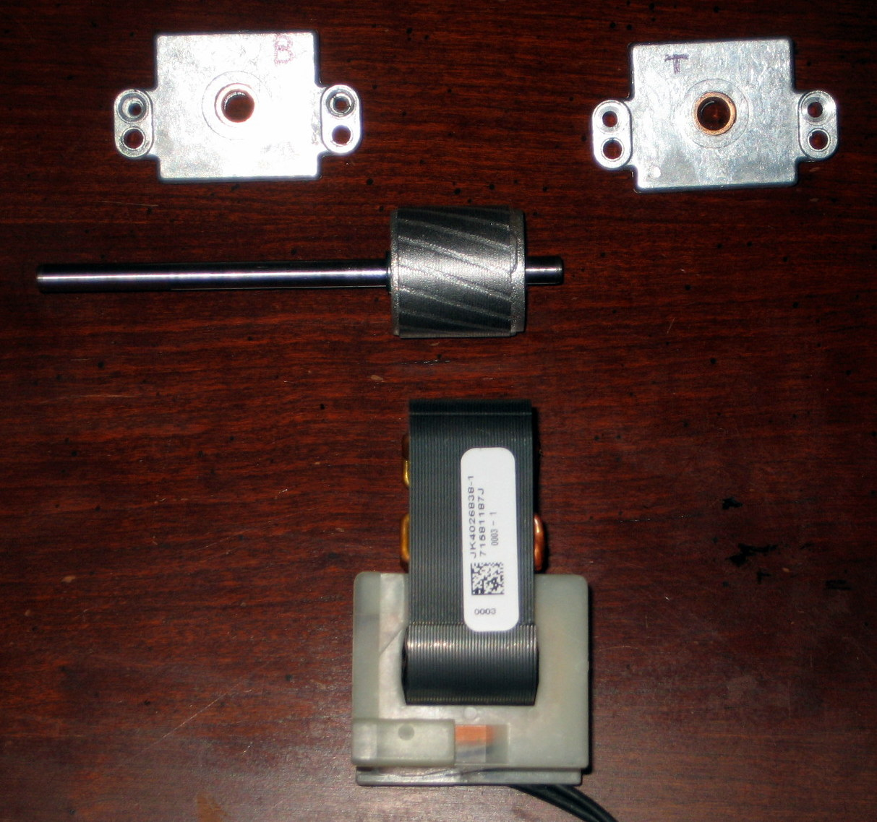

The motor is disassembled prior to tapping the #12 x 24 threads in the precast aluminum holes next to the motor assembly bolts.

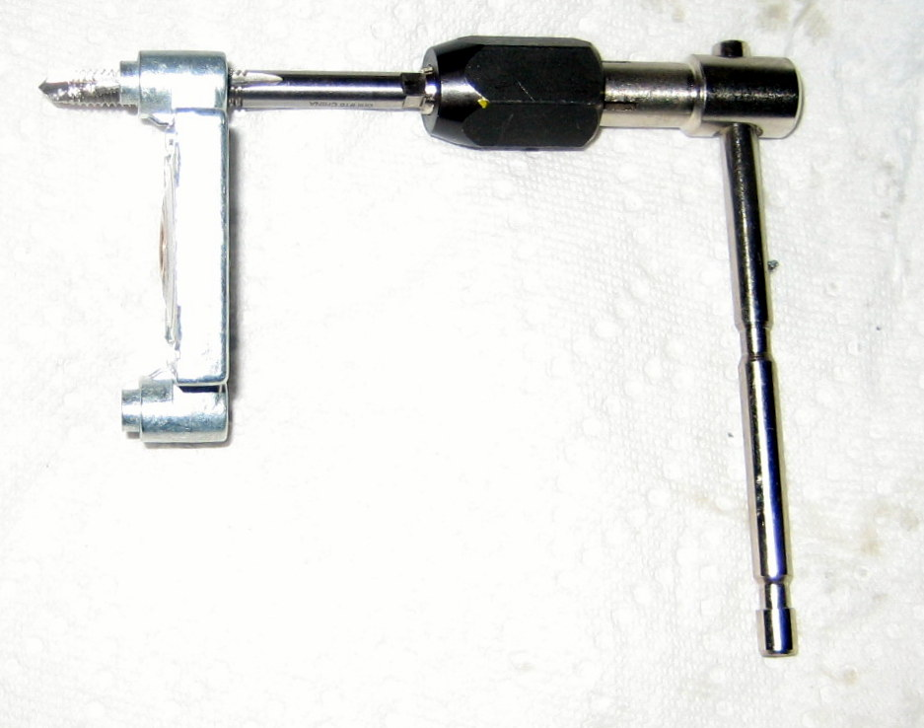
Purchased the # 12 x 24 thread tap and turning tool at Fastenal while there since the prices were actually less than for similar items at Lowe's.

The photo is the tap in one of the four holes which were all eventually tapped.

While waiting for the special order bolts to arrive from Fastenal I had to determine what to do about the blower wheel. An alternative to purchasing one is to attempt to remove the blower wheel hub from the original 3/16" motor shaft. If removed one could use a drill press to gradually drill out the hub from 3/16" to 1/4" by using 1/64" increment drills. Hopefully, this could be accomplished without a wobbling result on the shaft. The hub also needed to be shortened and possibly tapped for a set screw or two.

As a result, a decision was made to purchase a new blower wheel rather than attempt modification. Searched to locate a blower wheel close in size to the original which is 2 3/4" in diameter and 1 1/4" in width. Eventually found a wheel 2 1/2" in dia., 1" wide with a 1/4' shaft and Counterclockwise Rotation (Please refer to the following Rotation Note) on the website blowerwheel.com with part number #02160100-008-S-AA-CCW-01 and ordered it.

Blower Wheel Rotation Note:

I found that different suppliers utilize different rotation notations so you need to be very careful to check the rotation from your particular source. For example, the emotorstore.com also carries blower wheels but their notation is different from blowerwheel.com. A CW rotation blower wheel at emotorstore.com (they view from the open end) is equivalent to a CCW rotation at blowerwheel.com (they view from the closed end).

Unfortunately, I wasn't expecting this and incorrectly ordered a CW wheel from blowerwheel.com and then had to exchange it for the CCW wheel referenced previously.

I would have preferred to have a blower wheel wider than 1" and it appears with the tolerances one could have been installed up to 1 3/8" wide but did not find a source for one. If someone finds a source with vender, manufacturer and model number please advise so that the blower wheel information may be updated for others.
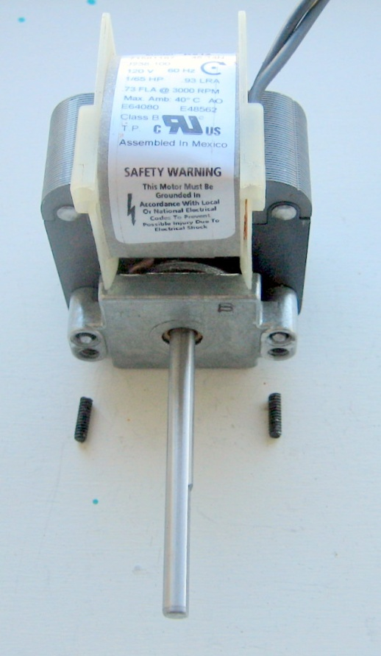

LONG MOTOR BOLTS CUT OFF WITH A DREMEL TOOL (Incorrect Motor Assembly)

After the long motor bolts were cut off I learned that previously I had accidently reassembled the motor incorrectly during the first test fit.

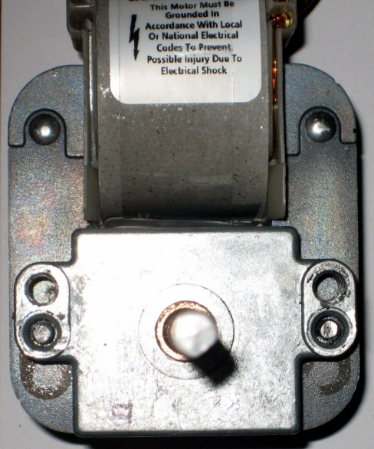

CORRECT MOTOR ASSEMBLY (Note location of the newly tapped threads above the motor bolts in this photo.)
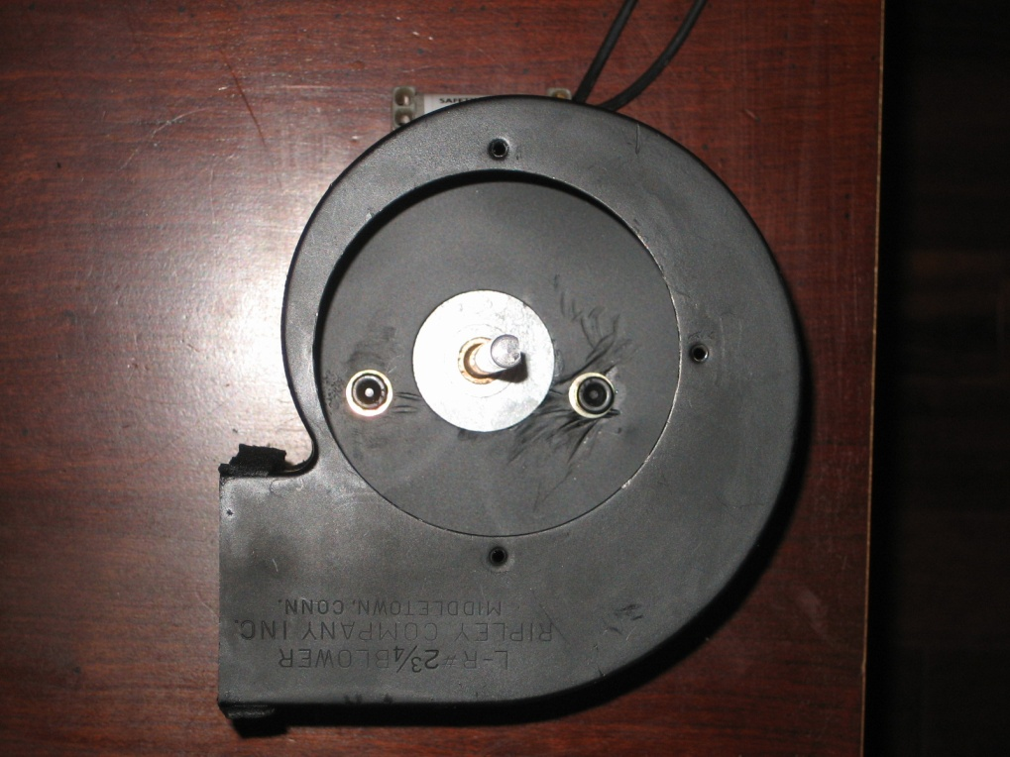

TEST FIT OF FAN HOUSING AND MOTOR

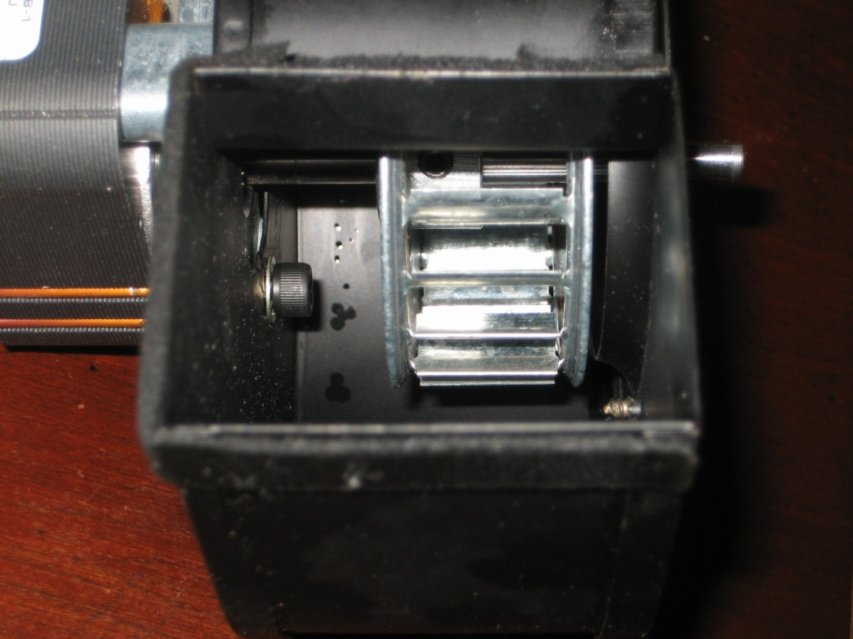

BLOWER WHEEL TOLERANCE CHECK
After receiving the #12 x 24 bolts and blower wheel from blowerwheel.com I cut off the bolt ends protruding from the motor and checked the motor/ housing fit. The first test fit revealed I needed to properly assemble the motor. On the second test fit, as suspected, they fit together perfectly. The blower wheel was attached with 5/16" clearance between the outer housing surface and the wheel (Measurement with the attached cowling removed). The extended shaft was measured from the end to the outside edge of the blower wheel hub with set screw and it was determined 1 7/16" of the shaft needed to be removed. However, prior to removal the components were assembled and mounted for a test fit and run to make sure the tolerances and mounting location of the blower wheel was adequate.

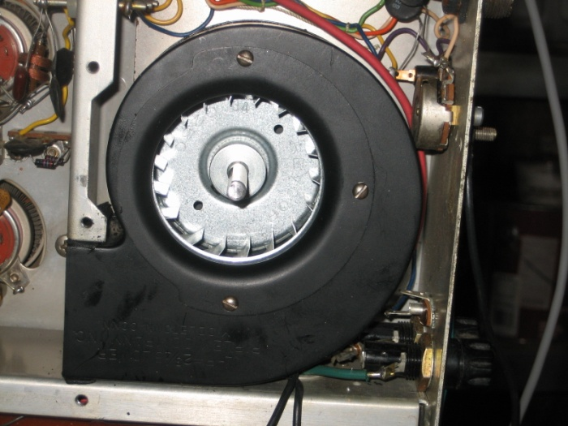

CHASSIS TEST FIT OF HOUSING

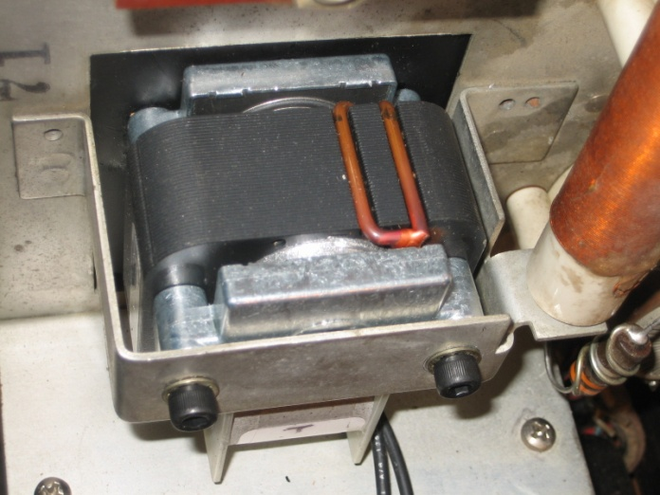

TEST FIT OF MOTOR CHASSIS MOUNT ( Note the old 1/4" metal spacers between the fan housing and new motor are not required.)
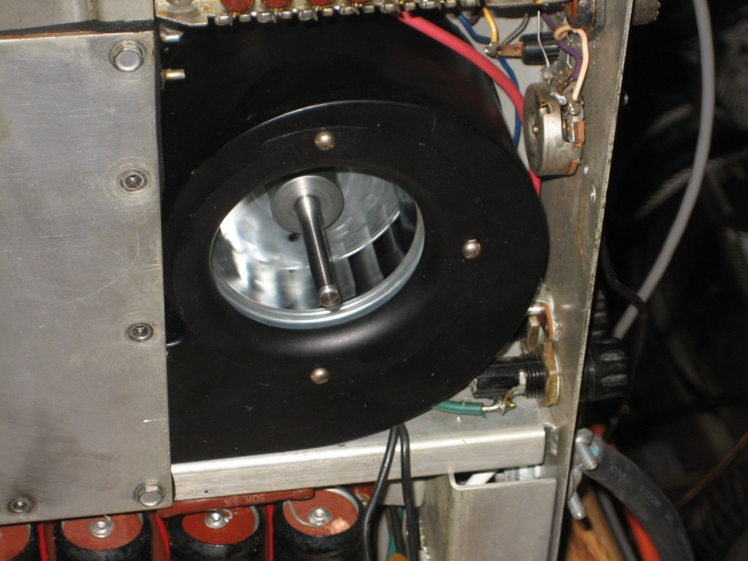

MOTOR TEST RUN

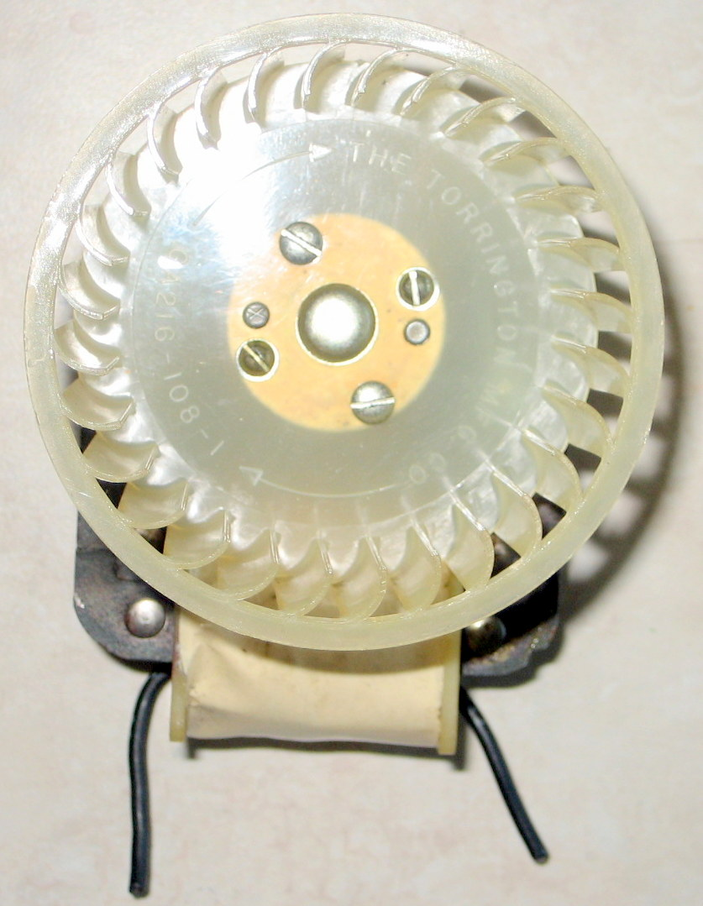

OLD MOTOR WIRES CUT AND MOTOR REMOVED
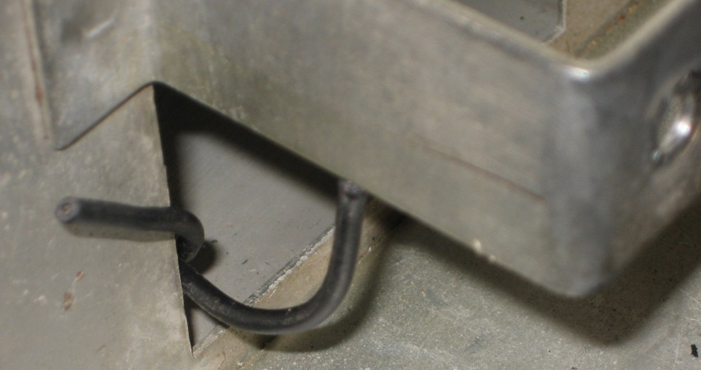

MOTOR POWER WIRES EXTENDING THROUGH CHASSIS

The motor power wires were cut about 1" to 1/14" from the motor winding and the wires ended up extending between 1 1/4" and 1 1/2" up through the chassis. The splice to the new motor power wires is planned to occur on the upper side of the chassis near the motor.

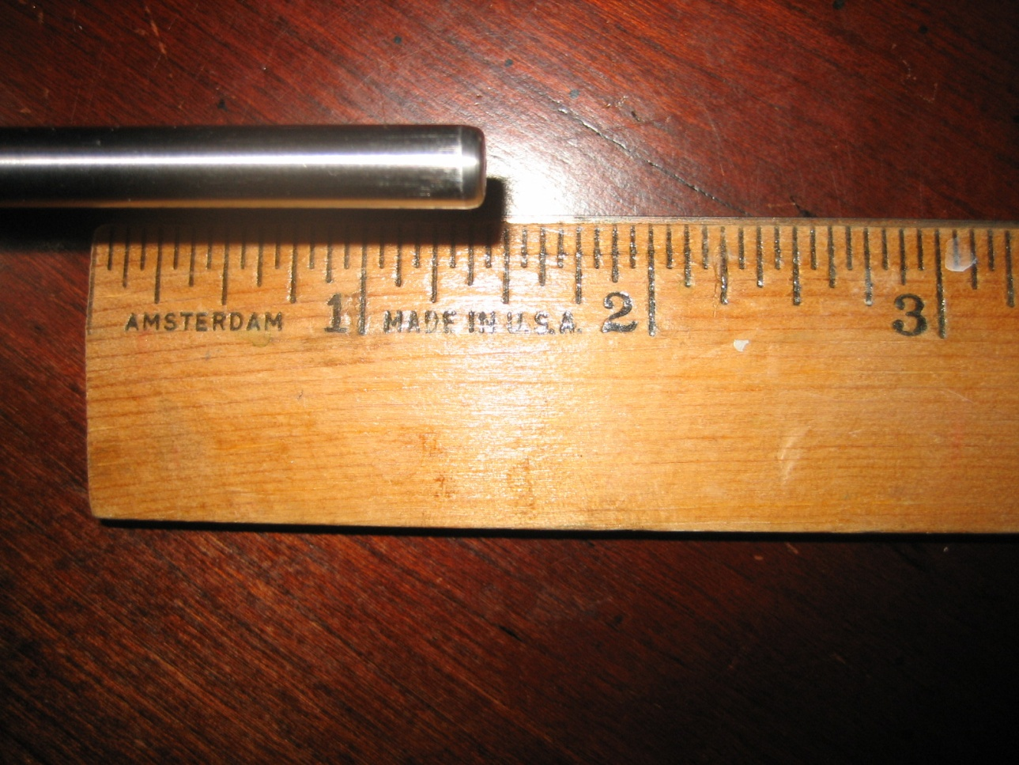

MEASURED TO REMOVE 1-7/16" FROM THE SHAFT
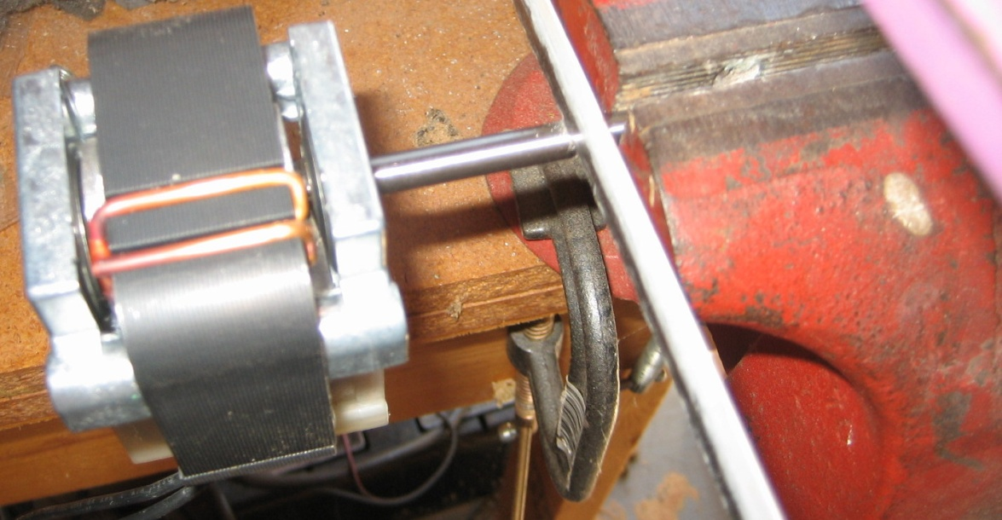

UTILIZED A HACKSAW TO CUT THE MOTOR SHAFT

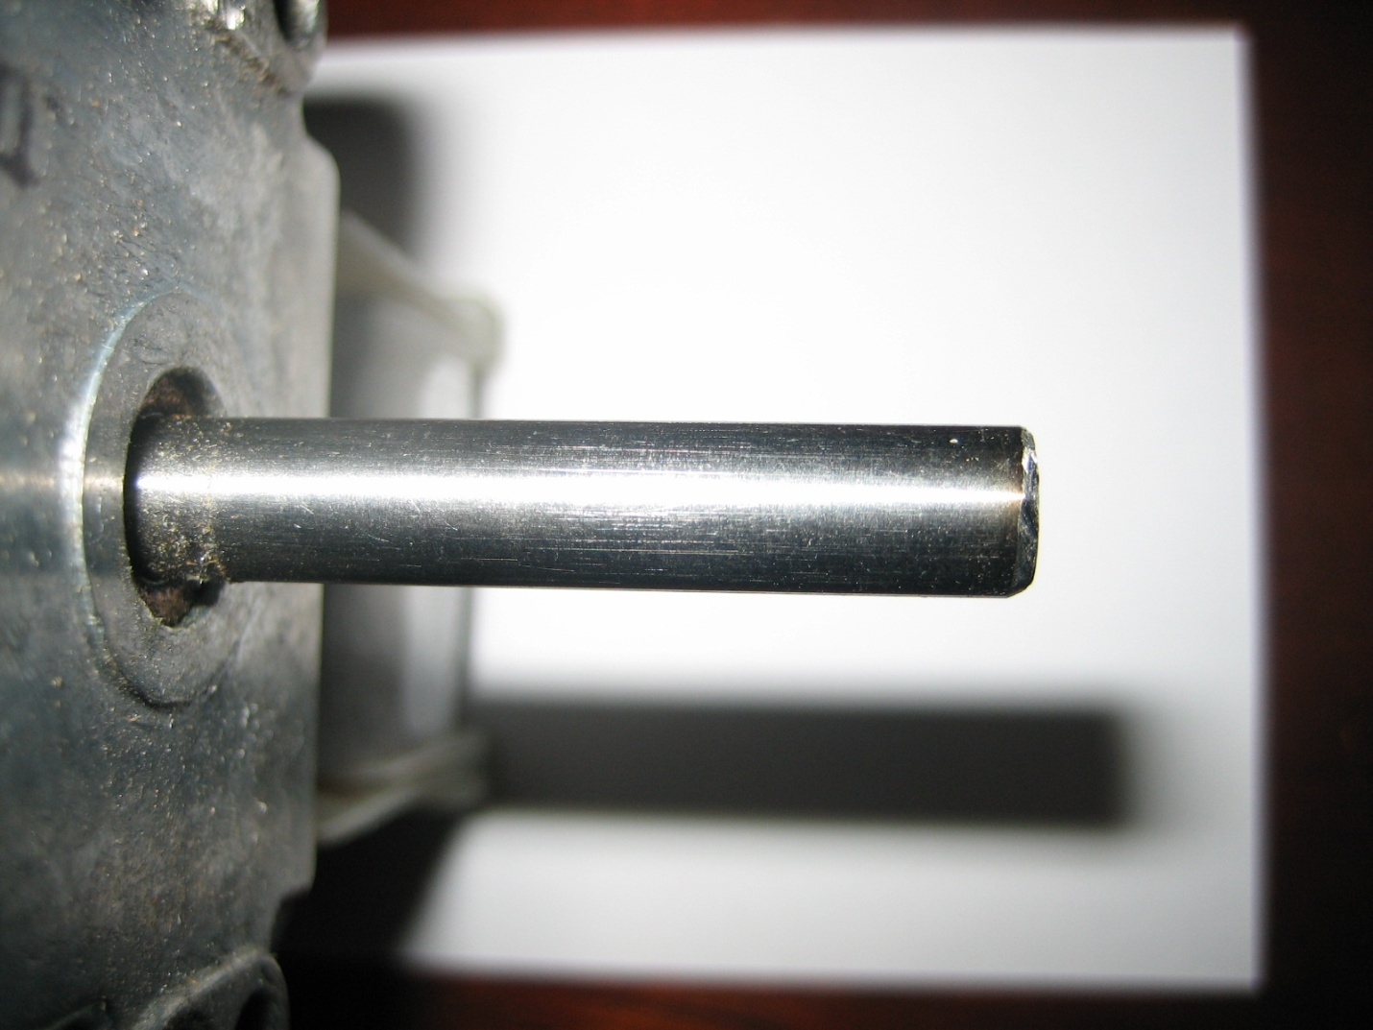

ENERGIZED THE MOTOR AND PUT A CHAMFER ON THE END OF THE SHAFT WITH A FILE TO REMOVE SHARP EDGES.
After cutting off the excess shaft material and filing a chamfer on the long end of the shaft, the fan motor, blower wheel and housing were re-assembled and tested on last time prior to removing the motor power receptacle.

After a successful tolerance test the motor power wires were routed in such a manner as to provide maximum length in case the motor required removal in the future. The motor power wires were cut to allow a 1" overlap with the wires protruding up from the chassis. The insulation on all four wires were stripped 1/2". Heat shrinkable tubing 3/16" and 1/4" by 2" was slipped back over the motor side of the wires, the wires were spliced with a 1/4" overlap, twisted around each other and soldered. The 3/16" tubing was slipped over the connections and heated. Likewise with the 1/4" HS tubing.

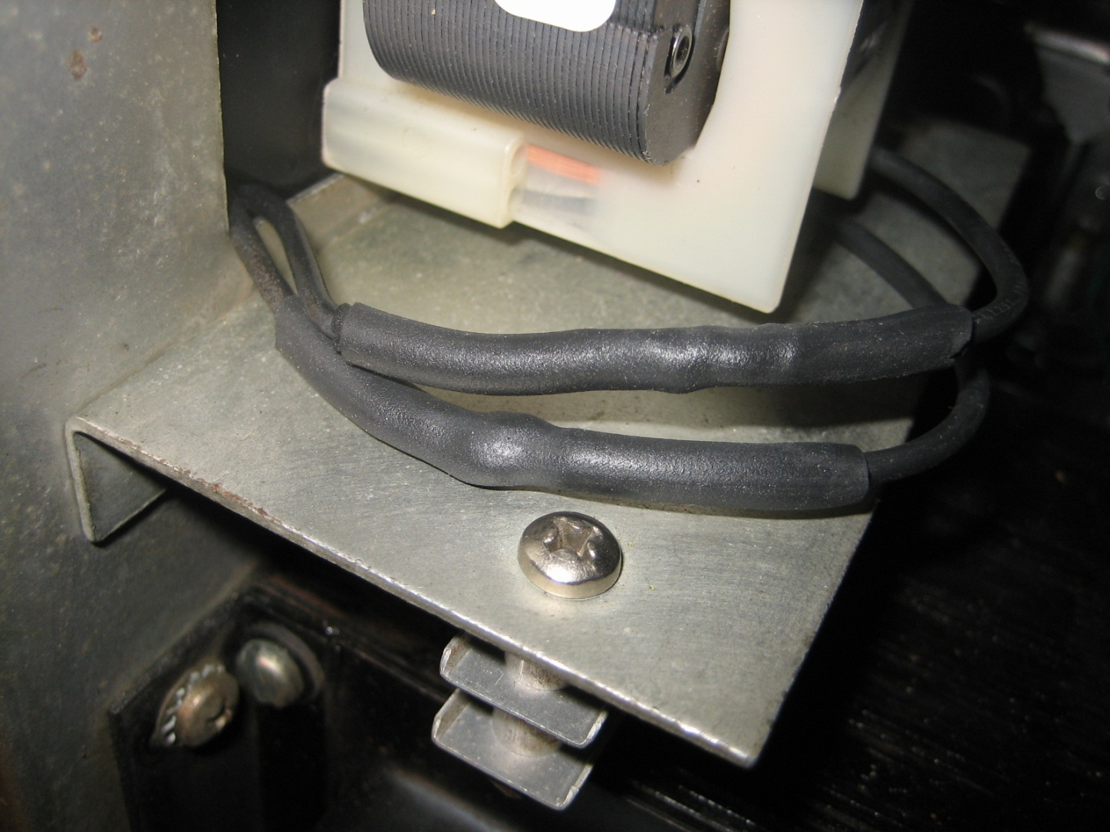

3/16" AND 1/4" HS TUBING APPLIED OVER THE SOLDER CONNECTIONS.

The amplifier chassis was re-assembled in the cabinet and powered up.

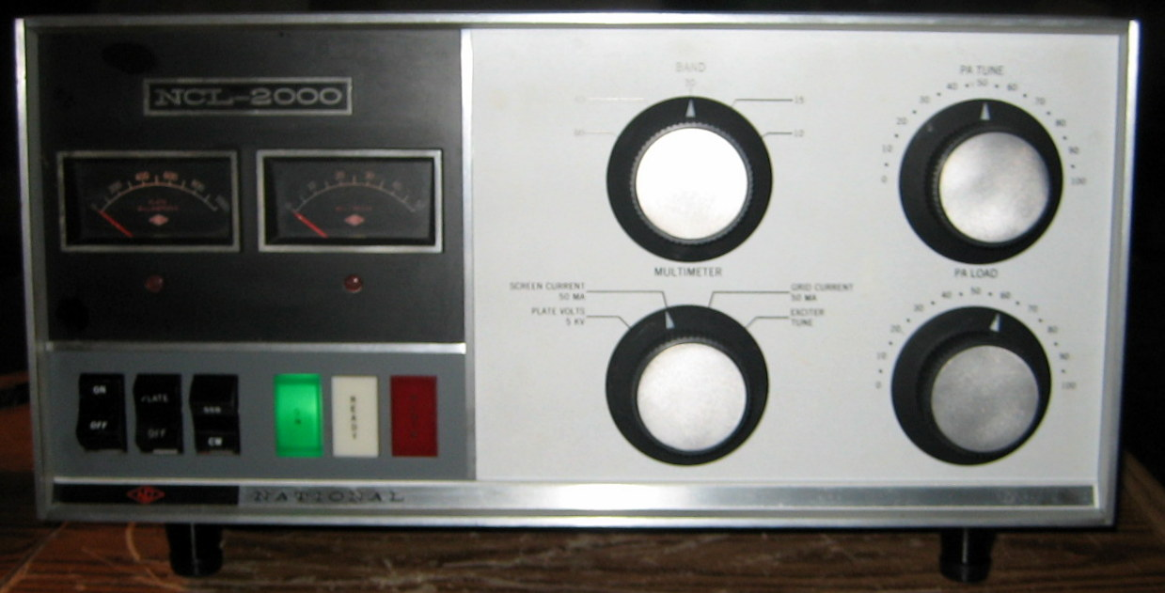

If anyone has questions or comments please contact me via the QRZ email address for KM4DR.

